Position Applied for |  | Job Ref (if known)

Personal and Contact Details:
Full Name: |  | Title:  Forenames:  Surname/Family name:
Known as:
Full address including postcode:

Telephone numbers: |  | Mobile: Landline:
Email: (will be used for most correspondence)

Linked in: (not obligatory)
Nationality |  | Do you have the right to work in the UK and a current work permit or visa? (if so, provide details)
Driving Licence | Full |  | Driving Convictions | Details
 | Provisional
 | None

Education and Academic Qualifications:
(Please state institution attended and qualifications gained with grade)
Continue on a separate sheet if necessary
Name of Secondary School(s) | Qualification, Subject and Grade
Name of College(s) / University(ies) | Qualification, Subject and Grade (or expected grade)

Employment History: Key position(s) held and summary of duties/responsibilities:
(Start with current / most recent employer) Continue on a separate sheet if necessary.
Employer | Position held | Dates | Summary of duties/responsibilities

Time not already accounted for:
Please give details of time not accounted for above (including unemployment)

Current Salary (full-time equivalent): |  | Other benefits of current employment package (e.g. pension)
Notice period:

Professional Qualifications:
Institution / Society | Grade of Membership

Technology:
Please list the software packages/programming languages, and your level of proficiency, that you are familiar with. Use the list provided in the table below as a guide and provide specific names of software packages used.
 | Beginner | Competent | Advanced
Word Processing
Spreadsheets and Databases
Programming languages
Geographic Information Systems
CAD systems
Hydraulic modelling
Hydrology
Other(s)

Other Skills/Qualifications/Training Courses attended:
Description | Awarding Body | Years held

Any other information which may support your application (e.g. personal profile, membership of clubs/societies, hobbies and interests etc.) Continue on a separate sheet if necessary.
Why did you apply for this role, and why do you think you are the best person for the job?
References will be required if you are offered and accept a job with JBA.

General Information:
How did you find out about this vacancy? This information is for internal feedback use only and will not be disclosed to any third party.
For speculative applications only please indicate which JBA office you would prefer to work if available.
Number in order of preference where 1 = your first choice. Cross out any office that you are not prepared to work at.
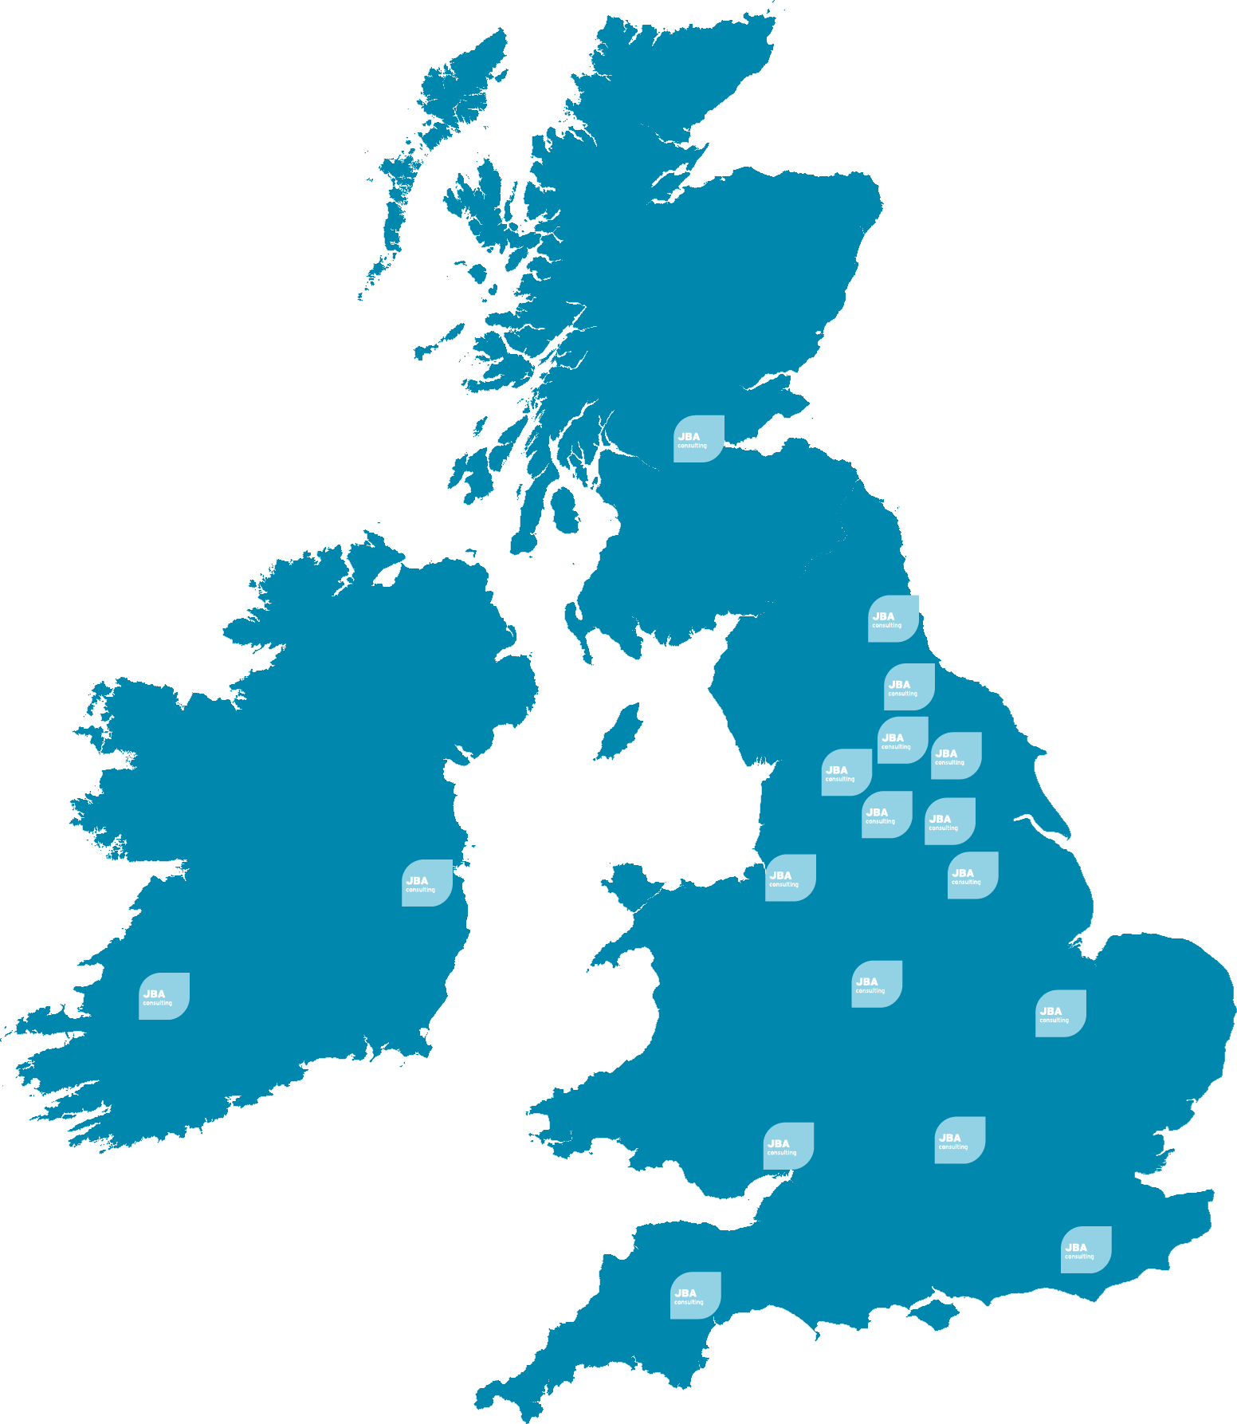 | Coleshill, Warwickshire |  | Newcastle-upon-Tyne
 | Doncaster, South Yorkshire |  | Newport, S Wales
 | Dublin, Ireland |  | Peterborough, Cambs
 | Edinburgh, Scotland |  | Portsmouth, Hampshire
 | Exeter, Devon |  | Saltaire, West Yorkshire
 | Haywards Heath, W Sussex |  | Skipton, North Yorkshire
 | Leeds, West Yorkshire |  | Tadcaster, North Yorkshire
 | Limerick, Ireland |  | Wallingford, Oxfordshire
 |  |  | Warrington, Cheshire

Equal Opportunities:
JBA is committed to the application of the Equality Act 2010 (UK); Employment Equality Acts 1998, 2004 (Ireland); and Employment Act 1991 and Employment (Amendment) Act 1996 (Isle of Man).

In order to assist in monitoring and reporting equality information and to record our progress in achieving the aims of our Equality & Diversity Policy we would be grateful if you would complete our separate confidential Questionnaire (also available from the careers section of our website) and to return a copy with this completed application form.

All information will be treated in confidence and will not be seen by staff directly involved in the selection process. The questionnaire will be detached from your application form, stored separately and used only to provide statistics for monitoring purposes.

Your cooperation would be appreciated but completion of the form is not obligatory. Thank you for your assistance.

Disability:
Do you consider yourself to have a disability or specific health condition that requires assistance?
Please tick: | Yes: |  | No:
If you responded yes above; do you require any special arrangement or adjustment to help you attend an interview if you are successful at the sift stage? Please give details. Your answers will be treated confidentially and will not affect your application in any way.

